**Database Design**

**03.18.2024**

**Mary Jines**

**SWDV 691 Capstone**

**Maryville University**

**OVERVIEW**

Initially, I considered using SQLite for this project for the simplicity. It is the default database for the Django framework which I will be utilizing, it is free, and despite its limitations as far as scalability, would suffice for the scale of this project which is not very large. However, after some reading and more careful consideration, I have decided to use PostgreSQL to complete this project for a few reasons:

1. The use of PostgreSQL over SQLite will provide me with more real-world practice.
2. The nature of the data for this project is highly normalized with many-to-many relationships, and there is the possibility of frequent updates. Both of these characteristics are better served by a relational data store like PostgreSQL or MySQL. SQLite is relational, but it cannot function on the same level as a full-scale database like PostgreSQL or MySQL.
3. After some reading, it seems that PostgreSQL might be slightly better supported by Django with lots of community use and resources.
4. I can use it for free.
5. Redundancy can be limited by the normalization of data into different tables. For example, user information will be stored once in the user table, but referenced in other tables where necessary by foreign keys.

**DATA STRUCTURE**

**Tables:**

**_____________________________________________________________________________________**

**Users: This table will store the user data necessary for account creation and authentication / login.**

user_id (Primary Key, Integer)

username (Text)

email (Text)

password (Text)

**_____________________________________________________________________________________**

**TrainingSessions: This table will store training sessions entries associated with a particular user.**

session_id (Primary Key, Integer)

user_id (Foreign Key to Users, Integer)

date (Date)

duration (Interval)

notes (Text)

techniques (Text)

**_____________________________________________________________________________________**

**Techniques: This table will store technique library entries associated with a particular user.**

technique_id (Primary Key, Integer)

user_id (Foreign Key to User, Integer)

name (Text)

type (Text)

description (Text)

proficiency_level (Text)

**_____________________________________________________________________________________**

**Technique Relationships: This table creates the relationships that specific techniques from the table above can have with other techniques. A technique can have multiple related techniques and be referenced multiple times as a related technique.**

relationship_id (Primary Key, Integer)

technique_id (Foreign Key to Techniques, Integer)

related_technique_id (Foreign Key to Techniques, Integer)

**_____________________________________________________________________________________**

**Media: This table will store media submissions from a user and reference a file path.**

media_id (Primary Key, Integer)

user_id (Foreign Key to Users, Integer)

file_path (reference to the file location in AWS S3, Text)

media_type (Text)

upload_date(Date)

**_____________________________________________________________________________________**

**Technique Media: This table establishes the many-to-many relationship between media and techniques.**

technique_media_id (Primary Key, Integer)

technique_id (Foreign Key to Techniques, Integer)

media_id (Foreign Key to Media, Integer)

**_____________________________________________________________________________________**

**Session Media: This table establishes the many-to-many relationship between media and training sessions.**

session_media_id (Primary Key, Integer)

session_id (Foreign Key to TrainingSessions, Integer)

media_id (Foreign Key to Media, Integer)

**ER DIAGRAM**

In the following diagram you will see the various relationships between tables in the database. Users will have a one-to-many relationship with Techniques and TrainingSessions. Users will also have a one-to-many relationship with media. Techniques and TrainingSessions both have a many-to-many relationships with media, so there will be a linking table both for technique media and for training session media. Finally, techniques will have a many-to-many relationship with itself through a linking table that will establish connections between related techniques.

The diagram is oriented landscape for size. 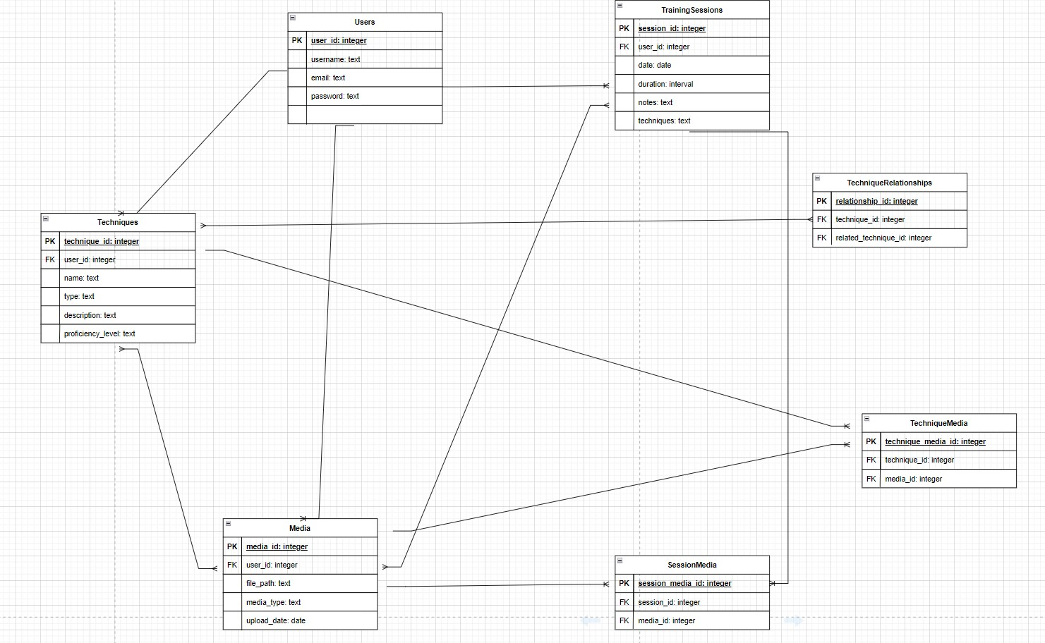**PURPOSE, IMPLEMENTATION, INTERACTIONS**

**Users**

**Purpose:**

This table is necessary for managing user accounts. It is what enables users to have personalized accounts with individual training journals and technique libraries, and relates to MVP (I): User Registration and Authentication.

**Implementation:**

Basic user information is stored in this table which is used for the login process.

**Interaction:**

Users use their credentials to log in to the application. Their input is checked against the user data in the table to verify identity.

**_____________________________________________________________________________________**

**TrainingSessions**

**Purpose:**

This table serves as the Journal portion of the application and is the core of the entire project. The table records the details of training sessions entered by users. It relates to MVP (II,III, and IV): Training Journal and Technique Library dashboards that display entries, CRUD operations for both the Training Journal and Technique Library, and Basic search functionality for the Training Journal and Technique Library

**Implementation:**

Each entry represents the important aspects of a training session like date, duration, and techniques practiced. This table links to the Users table so that each session is associated with a particular user.

**Interaction:**

Users can create new entries, update existing details, and review sessions as needed using the search function to track their progress over time.

**_____________________________________________________________________________________**

**Techniques**

**Purpose:**

This table creates the Technique Library which is equally as important to the application as the training journal. The table stores important information about different techniques.

**Implementation:**

Each entry to this table represents a BJJ technique and important details about it: name, type, description, and proficiency level. Techniques are associated with user accounts and with other techniques in order for users to be able to track related techniques.

**Interaction:**

Users can add new techniques, update existing techniques, and include important information about their proficiency level. They will also be able to mark existing techniques as related to a specific technique. Finally, they can search for a specific technique.

**_____________________________________________________________________________________**

**Technique Relationships**

**Purpose:**

This table links the relationships between different BJJ techniques, which serves to help users understand how different moves relate to one another or might be strung together in sequence.

**Implementation:**

The table creates many-to-many relationships between techniques, identifying which techniques pair well together.

**Interaction:**

As users learn how different techniques connect, they can update this table to reflect their growing understanding.

**_____________________________________________________________________________________**

**Media**

**Purpose:**

The Media table stores resources like images and videos, which provide an additional layer of resources for users to understand a technique or recall a particular training session.

**Implementation:**

Each record links to an AWS S3 file path where the media is stored. The table includes information like the type of media, upload date, and the associated user.

**Interaction:**

Users can upload pictures or video to document their techniques or training sessions. They can view and delete media files. The application will display media alongside technique descriptions or session logs.

**_____________________________________________________________________________________**

**Technique Media**

**Purpose:**

This is a linking table that establishes a many-to-many relationship between techniques and media, allowing for the association of multiple media files with multiple techniques.

**Implementation:**

Records in this table link technique entries with media entries, enabling users to view relevant images or videos directly within technique descriptions.

**Interaction:**

When a user adds or reviews a technique, they can link new or existing image or video to the technique.

**_____________________________________________________________________________________**

**Session Media**

The purpose, implementation, and interaction of the Session Media table is the same as the Technique Media table, except in this case the association is create the many-to-many relationship that exists between media and training sessions, instead of the techniques.